Gifted Internship Application Packet
(Rising 11th & 12th graders, Cambridge High School)
Attention Parents & Students … FCS Gifted (TAG) Internship procedures have changed.
Please read all information in this document.

Mission and Vision: The FCS Internship Program collaborates with community partners to engage students in authentic career exploration opportunities, leading to college and career readiness.

Description: The Career Internship is an elective designed to prepare students for the realities of a particular profession. As a result of participating in this study the student will be able to:
- Identify and investigate career fields of interest.
- Develop research skills for selection of careers that match interests and values. Participate in on-site experiences with a selected professional.
- Interns are unpaid, as students receive Georgia High School Graduation Credits for their efforts. The Internship Program Advisor, Internship Site Supervisor, and the Internship Program Teacher work with the student in completing a successful internship.

Prerequisite Requirement Check List:
Student must be a rising Junior or Senior _____
Student must have an unweighted GPA of 90 or higher _____
Student is enrolled in the FCS Gifted Program _____
Student must have room in schedule to take Internship course _____

Application Process and timeline:
- Student must turn in hard copies (printouts) of the following completed documents to Mrs. Kari Flores, room 1140 or Mrs. Ann LeClair-Ash, room 2722 by Thursday, February 29.
  - Gifted Internship Application
  - Internship Policies and Responsibilities Form signed by student and parent/guardian. Original [not electronic] signatures are required.
  - Students must remember to check their FCS and personal emails in order to keep current with the interview process.
- Student must provide a hard copy of the Teacher Recommendation Form (last page of this document) to the teacher identified in the Application as the recommending teacher by Thursday, February 29.
- In early March 2024, qualified students will participate in one-on-one interviews with the Internship Teacher.
- In early March 2024, intern selection will be conducted by a school-based committee. Relevant factors that will be considered include the applicant’s academic, attendance and discipline records; schedule; teacher recommendation and interview with Internship teacher.
- By March 12, 2024, students will be notified via email whether or not they have been approved to participate in the Internship Program.
- In March 2024, selected students will participate in a résumé writing workshop conducted by the Internship Program Advisors.
- In April/May 2024, internship placements will begin. Students are required to bring an approved résumé to the Site Placement interview. Students who do not interview in April or May will interview in August 2024.
- All Internship students are required to attend Internship class on campus beginning the first day of each semester until they are given permission to check out. Furthermore, they must check their FCS & personal email daily as well as any relevant courses in MS Teams or Canvas.
Gifted Internship Application
Student Legal Name | Click or tap here to enter text. | Grade | Click or tap here to enter text.
Student School Email address | Click or tap here to enter text. | GPA (100 pt) (unweighted) | Click or tap here to enter text.
Student Personal Email address | Click or tap here to enter text.
Student Phone Number | Click or tap here to enter text.
Parent’s Name | Click or tap here to enter text.
Parent’s Email address | Click or tap here to enter text.
Parent’s Phone Number | Click or tap here to enter text.

During which semesters do you plan to participate in the Internship Program?
☐ Fall Semester ☐ Spring Semester ☐ Both Semesters
How will you get to your internship?
☐ My Car ☐Parents Driving ☐Public Transportation

Please list the courses you intend to take next year. If the course will be virtual or Dual Enrollment, please indicate.
Fall Semester | Virtual | D/E | Spring Semester | Virtual | D/E
Click or tap here to enter text. | ☐ | ☐ | Click or tap here to enter text. | ☐ | ☐
Click or tap here to enter text. | ☐ | ☐ | Click or tap here to enter text. | ☐ | ☐
Click or tap here to enter text. | ☐ | ☐ | Click or tap here to enter text. | ☐ | ☐
Click or tap here to enter text. | ☐ | ☐ | Click or tap here to enter text. | ☐ | ☐
Click or tap here to enter text. | ☐ | ☐ | Click or tap here to enter text. | ☐ | ☐
Click or tap here to enter text. | ☐ | ☐ | Click or tap here to enter text. | ☐ | ☐

How many days absent from school Fall semester 2023? |  | How many days absent from school Spring semester 2023?
Excused: Click or tap here to enter text. | Unexcused: Click or tap here to enter text. | Excused: Click or tap here to enter text. | Unexcused: Click or tap here to enter text.

As part of this application process, your high school discipline record will be pulled. Please share anything you wish to disclose with respect to your disciplinary history here:
Click or tap here to enter text.
List all extracurricular activities including jobs, you plan to participate in next year including the days of the week/meeting times for each:
Click or tap here to enter text.
Special Skills (Include measurable skills related to desired internship (for example: software programs, certifications, etc.):
Click or tap here to enter text.
World Languages (Include level of proficiency – fluent, proficient, conversational):
Click or tap here to enter text.

The FCS Internship Program: Guidelines for Selecting A Career Umbrella
The purpose of the FCS Internship Program is to provide students with real-world career experiences. As a high school student, you may already have a sense of a future career path for you. Please understand that while the Internship Program Advisors work to place you in a field that is in the umbrella of your ultimate career goals, interns are not guaranteed placement in any narrow, specific career field under that umbrella. Valuable experiences can come from a variety of internship settings. Thank you in advance for selecting two umbrellas of career interest; the Internship Program Advisors will work hard to find you an experience in one of these career umbrellas.
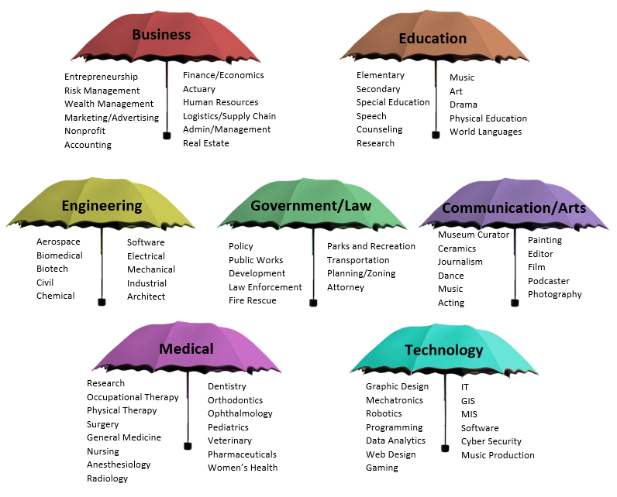
Check the box for each Career Umbrella area you would be interested in exploring through an internship. Each box checked indicates you are open to an internship within that career umbrella.
Choose at least two.
Business | ☐
Education | ☐
Engineering | ☐
Government/Law | ☐
Communication/Arts | ☐
Medical | ☐
Technology | ☐

Essay Questions
Answer each of the following essay questions to the best of your ability in 200 words or less.

The purpose of the FCS Internship program is career exploration and learning transferable skills which will benefit you in any professional environment.
If you are not provided an internship in your specific career field of interest, how will an internship in the broader career umbrella be of value to you?
Click or tap here to enter text.

Tell us about a specific weakness you've recognized about yourself in relation to your academic or professional journey. How has this weakness impacted your performance, and what steps have you taken or are currently taking to overcome it? Additionally, how do you believe addressing this weakness will contribute to your success in this internship role?
Click or tap here to enter text.

A high school intern is expected to intern five to seven hours per week in addition to their academic and extra-curricular activities. Describe a time you were overwhelmed with responsibilities and explain how you handled it.
Click or tap here to enter text.

Teacher References: One Teacher Reference is required. Please provide the attached recommendation form to your teacher no later than Thursday, February 29 and request that it be returned to the Internship Program Teachers (Ms. Flores or Ms. LeClair-Ash).
Teacher Name (First and Last):  Click or tap here to enter text. | Subject area:  Click or tap here to enter text.

FCS Internship Program Policies
The FCS Internship Program collaborates with community partners to engage students in authentic career exploration opportunities, leading to college and career readiness.

Students who are eligible to apply for the Internship course are rising Juniors and Seniors, are in good standing in the Gifted Program and have an unweighted GPA of 90 or higher. Students who have previously taken the seminar “Hire Me” must complete this application as well.

Submission of an Internship application does not guarantee admission. Selection for Internship is competitive and will be based upon the applicant’s academic, attendance and discipline records; schedule; teacher recommendation; interview with Internship teacher and review by Committee.

Interns must have reliable transportation to and from internship several afternoons per week. Internships will not be scheduled around driver availability and must remain consistent. It will not be acceptable for interns to miss internship based on lack of transportation.

Internship is a unique learning experience that takes place both in the classroom and at an off-site internship placement. Thus, in addition to the internship experience, interns are required to submit graded assignments and to conference with the Internship course teacher. The Internship Teacher may require students with missing work to remain on campus on non-internship days to complete work.

Interns will report to class until released by the Internship course teacher to commence the internship experience.

Interns will be placed in an internship within one of two broader career umbrellas they have identified as career areas of interest. Internship in a specific career field is not guaranteed. Refusal of an internship placement within the student’s selected career umbrella may result in the student being placed in a Directed Study for the duration of semester.

Once the internship experience begins, interns will complete a minimum of 5 hours per week at their internship sites. The five-hour requirement is based on the seat hours required for a high school course. Total Internship hours for the semester should be at least 70 hours. Internships last from the time of placement until the end of the semester regardless of hours completed.

Internships can be terminated by the internship site or the school for cause and will result in the intern being placed in a Directed Study for the duration of the semester. Students dismissed from their internship sites due to unsatisfactory performance will not be eligible to intern with this program in the future.

Student’s Responsibilities
- Meets all required academic standards for high school graduation.
- Adheres to all terms, regulations, and conditions of the Internship Program, Placement Site, and School.
- Abides by all school and internship placement site attendance, conduct, and discipline policies.
- Complies with school-based attendance policies for internship.
- Consistently reports to internship as scheduled.
- Interns a minimum of 5 hours no more than 7 hours maximum per week to be counted toward class credit, expect for preapproved field trip opportunities or special events. Total Internship hours for the semester should be at least 70 hours. Internships last from the time of placement until the end of the semester regardless of hours completed. The Internship program teacher will provide the end date.
- Submits timesheets to the Site Supervisor to confirm total hours earned weekly.
- Completes Internship Site onboarding orientation or paperwork if provided.
- Communicates with both site supervisor and internship teacher with any concerns or questions.
- Exhibits professionalism, positive work habits, and behavior at the internship site and in the classroom.
- Maintains appropriate appearance for the internship placement site.
- Arranges for reliable transportation to and from the internship site.

I have read and completed all applicable portions of the application and understand and agree to the policies and expectations of the Internship Program.

Student’s Signature |  | Date

Parent/Guardian Responsibilities
- Encourages the student to participate in the program and to carry out his/her duties effectively.
- Encourages professionalism, positive work habits, behavior, and ethics.
- Supports all aspects of the internship program.
- Ensures that the student consistently reports to the internship as scheduled.
- Immediately communicates any concerns regarding the internship to the on-campus internship program teacher.
- Signs onboarding paperwork as necessary.
- Arranges for reliable transportation to and from the internship placement site.

I have read and completed all applicable portions of the application and understand and agree to the policies and expectations of the Internship Program.

Parent’s Signature |  | Date

Internship Program Teacher Recommendation
Student Name
Teacher’s Name
Courses taught

Thank you for completing this recommendation for the FCS Internship program. The following characteristics are critical to an intern’s success and the continued success of the FCS Internship Program. Your candid evaluation is important. Please check the appropriate boxes below and turn this document directly to Mrs. Kari Flores, room 1140 or Mrs. Ann LeClair-Ash, room 2722 by Friday, March 8.

 | Excellent | Good | Fair | Poor
Communication Skills: Evaluate the student’s oral and written communication skills.
Initiative: Evaluate whether the student seeks out additional responsibility, identifies problems and solutions.
Cooperation: Evaluate how well the student works with peers and teachers.
Work Ethic: Evaluate how consistently the student works diligently without prompting.
Quality Work Product: Evaluate the extent to which the student’s work is completed thoroughly with attention to detail.
Reliability: Evaluate whether you would want this student to work on an important project with you.
Trustworthiness: Evaluate whether you would trust this student with important documents/confidential information.
Attendance and Punctuality: Evaluate whether the student is frequently absent or tardy.
Resilience: Evaluate the student’s ability to take constructive criticism.
Commitment to Continued Learning: Evaluate the extent to which the student seeks out additional learning experiences and asks insightful questions.

Additional comments:

Teacher’s Signature |  | Date

